🧠 AI-HAT (V1) — TECHNICAL EXECUTION PLAN
This is structured into:
- System Architecture
- Detailed Process Flow
- UI/UX Plan (Screen-by-screen)
- Backend & Doctor Dashboard
- Hardware Integration Plan
- AI Module Design
- Data Flow & APIs

🏗️ 1. SYSTEM ARCHITECTURE (V1)
[User]
↓
[AI-HAT Device (Tablet + Vitals)]
↓
├── Edge Layer (UI + AI Triage Lite)
├── Integration Layer (Vitals Sync)
↓
[Cloud Layer]
├── Telemedicine Server (WebRTC)
├── Backend APIs
├── Database
↓
[Doctor Dashboard]

🔄 2. DETAILED PROCESS FLOW
🔹 MASTER FLOW
START
↓
User taps "Start Checkup"
↓
AI Symptom Intake (Voice/Text)
↓
AI generates structured summary + risk level
↓
Vitals captured (SpO2, HR, BP)
↓
Display combined report
↓
Prompt: "Consult Doctor?"
↓
IF YES → Initiate Video Call
↓
Doctor views data + interacts
↓
Prescription / Advice
↓
END

🔹 AI TRIAGE FLOW (Agent Logic)
Input: Raw user speech/text
↓
Speech-to-Text (if voice)
↓
Symptom Extraction
↓
Keyword + Intent Mapping
↓
Risk Scoring Engine
↓
Output:
- Symptoms list
- Duration (if captured)
- Risk: Low / Medium / High

🔹 DOCTOR FLOW
Doctor logs into dashboard
↓
Sees incoming consultation request
↓
Accept call
↓
Views:
- Patient summary
- AI triage output
- Live vitals
↓
Consults via video
↓
Uploads prescription / notes
↓
Session ends

🖥️ 3. UI / UX PLAN (VERY IMPORTANT)
Keep this ultra-simple. Your users may be:
- Workers
- Rural population
- Non-tech users

🔹 SCREEN 1: HOME
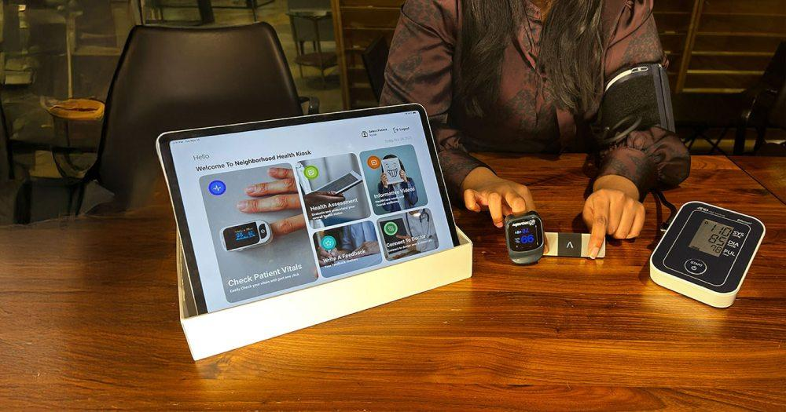
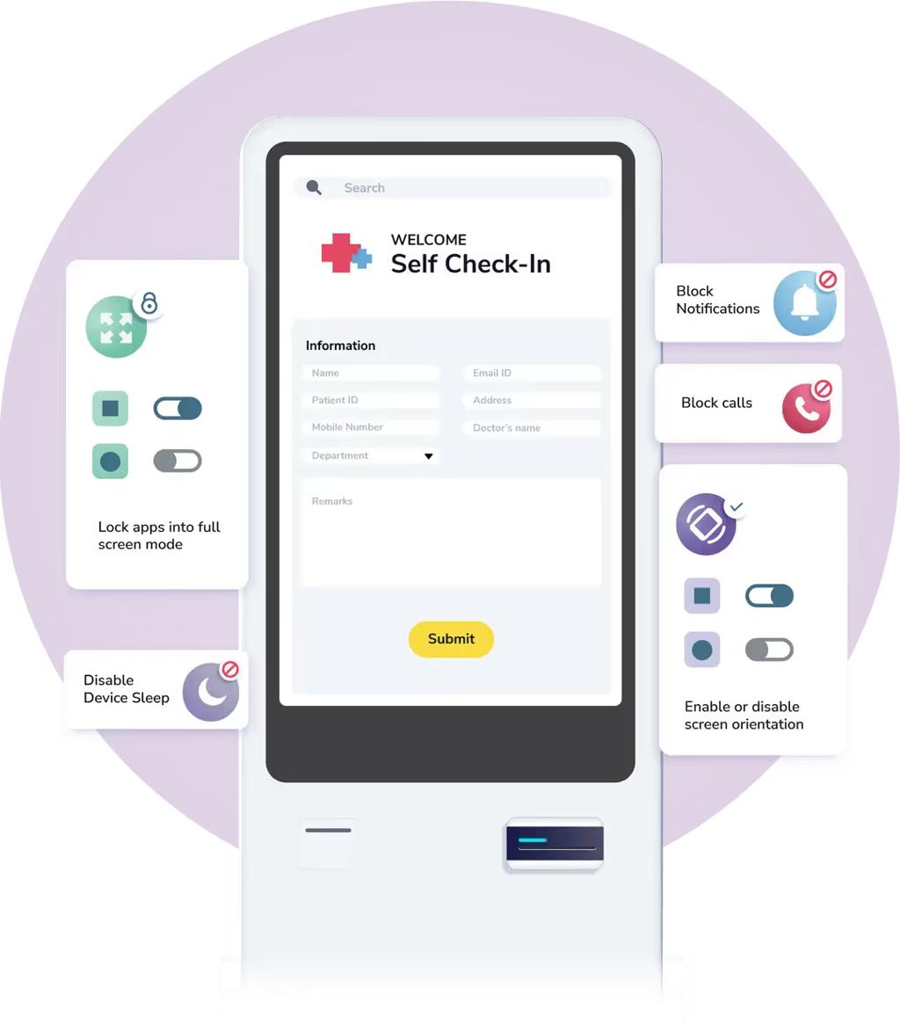

6
Elements:
- Big Button: “Start Checkup”
- Language selection (top corner)
- Optional: Emergency button (future)

🔹 SCREEN 2: AI INTERACTION
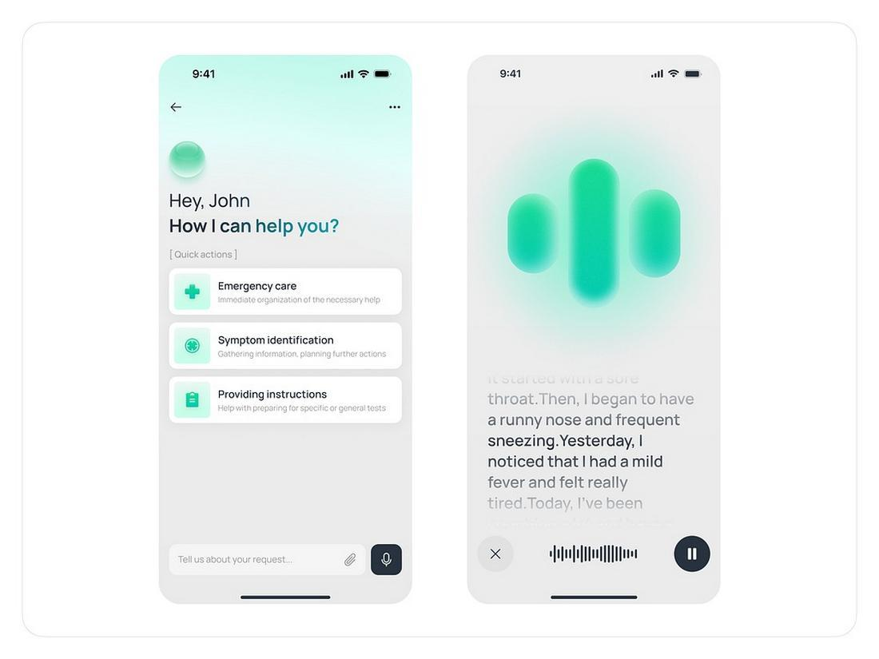
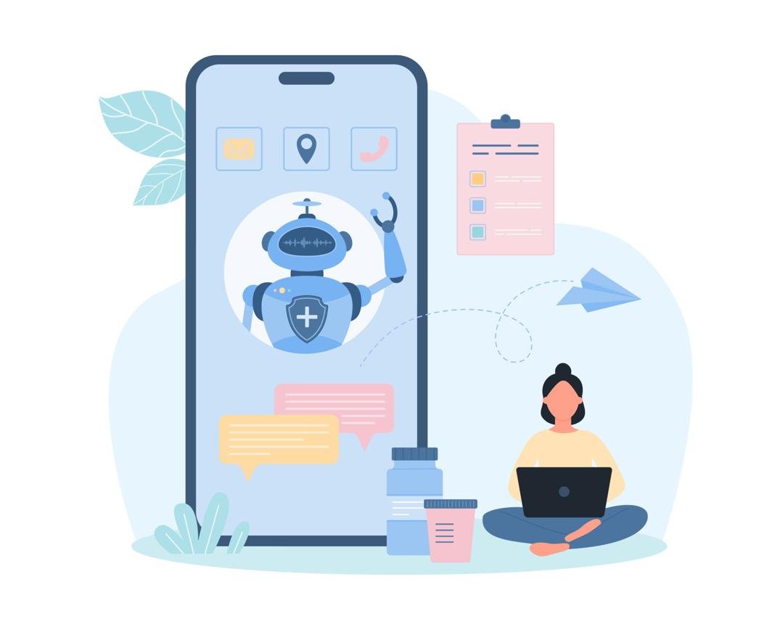

7
Elements:
- “Tell me your problem”
- Mic button 🎤
- Text fallback input
- Chat-style interaction

🔹 SCREEN 3: VITALS DISPLAY
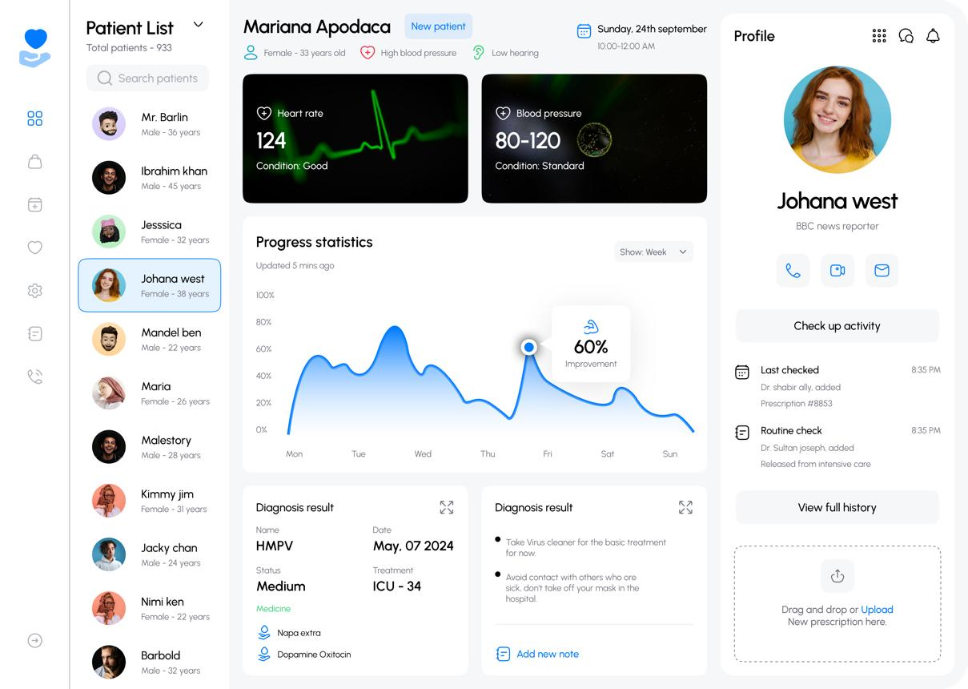
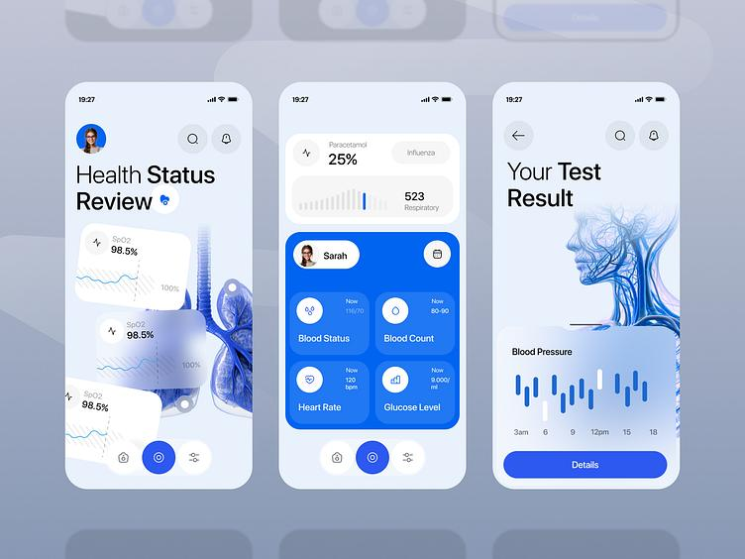
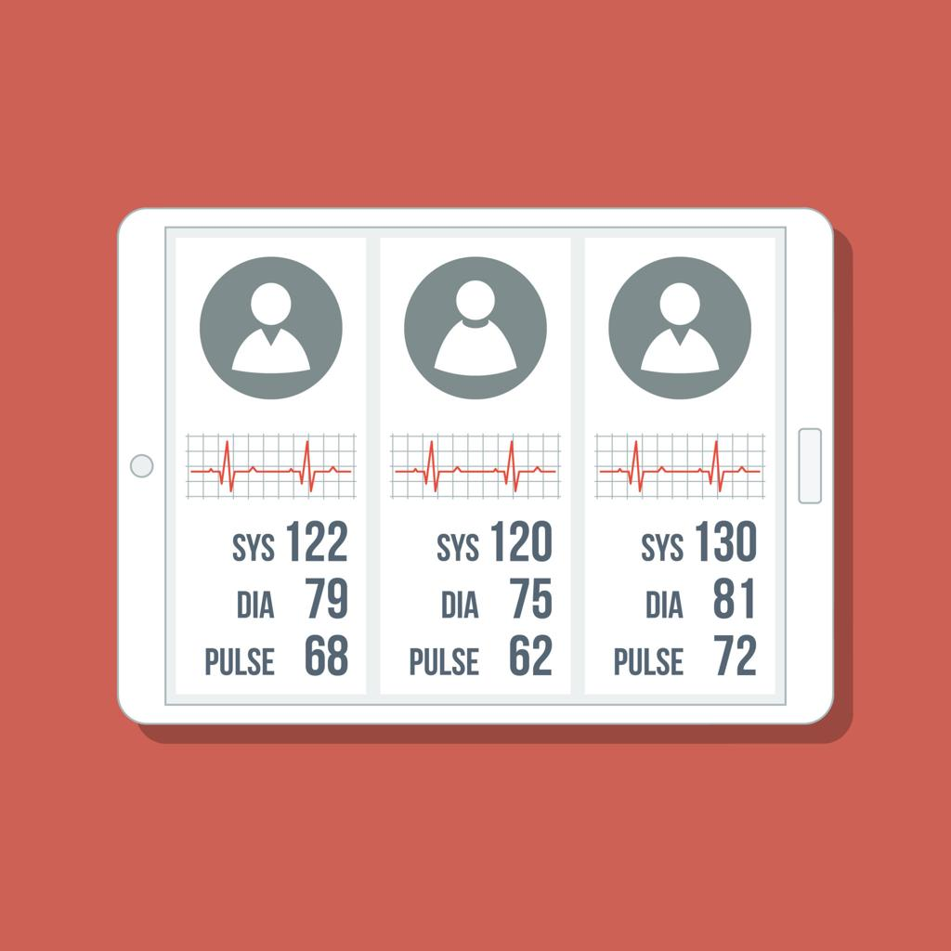
6
Elements:
- SpO2
- HR
- BP
- Status indicators (Normal / Alert)

🔹 SCREEN 4: SUMMARY + DECISION
Show:
- AI Summary
- Risk Level (Color-coded)
  - Green / Yellow / Red
Button:
👉 “Connect to Doctor”

🔹 SCREEN 5: VIDEO CONSULTATION
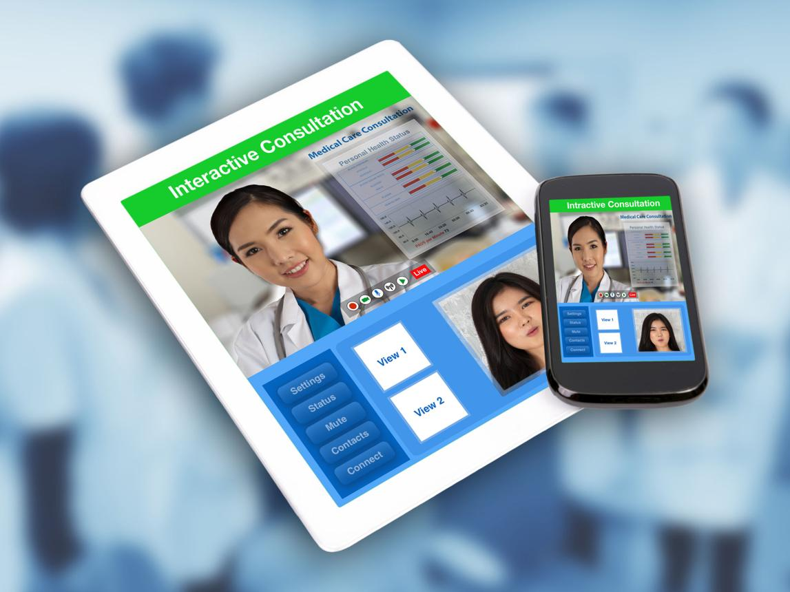

6
Layout:
- Doctor video (main)
- Patient preview (small)
- Side panel:
  - Vitals
  - AI summary

🔹 SCREEN 6: END SCREEN
- “Consultation Completed”
- Option:
  - View prescription
  - Print / Download

🧑‍⚕️ 4. DOCTOR DASHBOARD (WEB)
Core Modules:
1. Live Queue
- Incoming patients
- Risk level tags
2. Consultation Screen
- Video panel
- Patient info
- AI summary
- Live vitals feed
3. Prescription Module
- Upload PDF / type notes
4. History
- Patient logs
- Session records

🔌 5. HARDWARE INTEGRATION PLAN
Device:
- Android Tablet (preferred for speed)
Vitals Device:
- Choose one with:
  - Serial / Bluetooth / API output

Integration Flow:
Vitals Device → Microcontroller (optional) → Tablet App
OR
Vitals Device → Direct Bluetooth → Tablet

Data Mapping Example:
Parameter | Source | UI
SpO2 | Sensor | Display
HR | Sensor | Display
BP | Device | Display

🤖 6. AI MODULE DESIGN (PRACTICAL)
Keep it SIMPLE in V1
Components:
- Speech-to-Text (Google / Whisper API)
- Rule-based + lightweight NLP
- Predefined symptom library

Example Logic:
Input:
“Chest pain and sweating”
Output:
Symptoms:
- Chest pain
- Sweating
Risk: HIGH
Recommendation: Immediate consultation

👉 Avoid:
- Deep diagnosis
- Complex ML initially

🌐 7. BACKEND & API STRUCTURE
Core APIs:
1. Patient Session API
- Create session
- Store symptoms
2. Vitals API
- Push real-time data
3. Telemedicine API
- WebRTC signaling
4. Doctor API
- Login
- Accept call
- Upload prescription

Suggested Stack:
Frontend (Device):
- Flutter / React Native
Backend:
- Node.js / FastAPI
Video:
- WebRTC (Agora / Twilio)
DB:
- PostgreSQL / Firebase

